**EXPERIMENT 6**

**DML COMMANDS (COLLEGE SCHEMA)**

**Aim:**

• 1)Insert 5 instances into the tables created in experiment 5.

• 2)Display the tables.

• 3)Add attribute course to student table then insert values.

• 4)Use update to set course for students.

• 5)Delete an attribute.

**Code:**

1)ALTER TABLE student ADD(gender varchar(10));

insert into student values(1,'Randheer','Male','DBMS',89,'B','Hyderabad');

insert into student values(2,'Ranjhan','Female','DBMS',92,'A','Hyderabad');

insert into student values(3,'Veer','Male','DBMS',70,'C','Hyderabad');

insert into student values(4,'Ahaan','Male','DBMS',40,'F','Hyderabad');

insert into student values(5,'Akshitha','Female','DBMS',58,'D','Hyderabad');

select * from student;

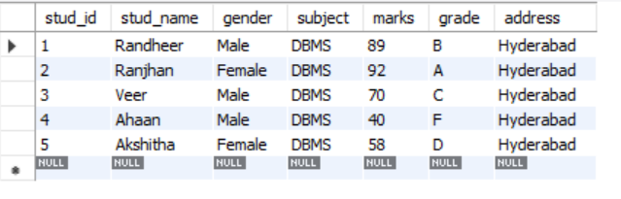

insert into faculty values(101,'Rajesh','Java',50,'CSE');

insert into faculty values(102,'Bapiraju','C++',50,'CSE');

insert into faculty values(103,'Shiva','DBMS',50,'CSE');

insert into faculty values(104,'Amritha','Python',50,'IT');

insert into faculty values(105,'Vashma','C',50,'CSE');

select * from faculty;

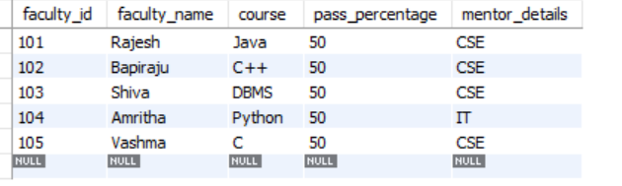

insert into department values(201,'CSE','A',63,50,60);

insert into department values(202,'CSE','B',64,50,58);

insert into department values(203,'CSE','C',65,50,56);

insert into department values(204,'IT','A',60,50,55);

insert into department values(205,'IT','B',60,50,50);

select * from department;

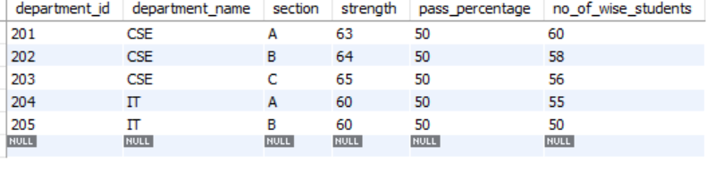

insert into activity values(1,'Singing',10,5,'Priya');

insert into activity values(2,'Treasure hunt',30,2,'Arjun');

insert into activity values(3,'Debate',8,6,'Shiva');

insert into activity values(4,'Rangoli',16,15,'Shreya');

insert into activity values(5,'Blind coding',35,1,'Ajay');

select * from activity;

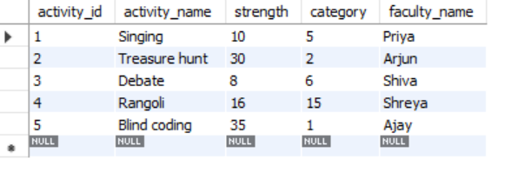

alter table student add(course varchar(20));

update student set course = "Python" where stud_id = 1;

update student set course = "C" where stud_id <6 and stud_id>1;

select * from student;

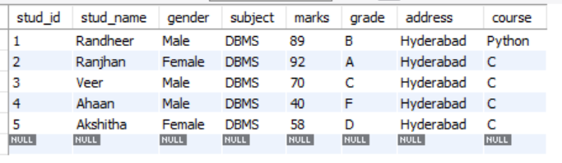

delete from student where marks<50;

select * from student;

